URL: <http://www.plazaclinic.net/>

Our goal is the prevention of the ongoing aging process. For that purpose we offer

1. Detailed consultation of your health status, supplements, and nutrition. Optional discussion about hormonal treatment.
2. Non surgical treatment such as botox restylane.
3. Traditional plastic surgical procedures.
4. Skin care and laser treatments.

With plastic surgery in Tokyo Japan all procedures are done by bilingual surgeons who are U.S. Board-Certified and trained in both Japan and the United States. These plastic surgeons practiced in the U.S. for more than 18 years and completed the UCLA and SUNY Chief Plastic Surgery Residency Programs.    English is spoken.

This is the only plastic surgery clinic in Japan, owned and operated by U.S. Board-Certified plastic surgeons.

**Non surgical procedures**

1. Botulinum Toxin A (Botox)

2) Hyaluronic Acid (Restylane, Juvederm)

3) Painless treatment is available for both Botox and Restylane injection (click for details)

Other applications of botox

* [Bruxism](http://www.plazaclinic.net/botox_related/bruxism.html)
* [TMJ pain (temporomandibular disorder)-Pain in the jaw joint](http://www.plazaclinic.net/botox_related/TMJ.html)
* [Hyperhidrosis of underarm (over-sweating)](http://www.plazaclinic.net/botox_related/underarm.html)
* [Slenderizing the jaw muscle](http://www.plazaclinic.net/images/4-c.jpg)
* [Slenderizing the legs](http://www.plazaclinic.net/botox_related/leg.html)
* [Stiff neck and shoulders](http://www.plazaclinic.net/botox_related/neck.html)
* [Tennis elbow](http://www.plazaclinic.net/botox_related/tennis.html)
* [Piriformis syndrome](http://www.plazaclinic.net/botox_related/priformis.html)
* [Thoracic outlet syndrome](http://www.plazaclinic.net/botox_related/thoracic.html)
* [Phantom pain](http://www.plazaclinic.net/botox_related/phantom.html)
* [Gastrointestinal pain](http://www.plazaclinic.net/botox_related/gastrointestinal.html)

**Surgical procedures:**

[Plastic surgical care for the wounds](http://www.plazaclinic.net/surgical.html#wound)

[Non-cutting Double Eyelids for Asians](http://www.plazaclinic.net/surgical.html#eyelids)

[Liposuction](http://www.plazaclinic.net/surgical.html#lipo)

[Fat Injection/Liposculpture](http://www.plazaclinic.net/surgical.html#fatinjection)

[Other procedures](http://www.plazaclinic.net/surgical.html#other)

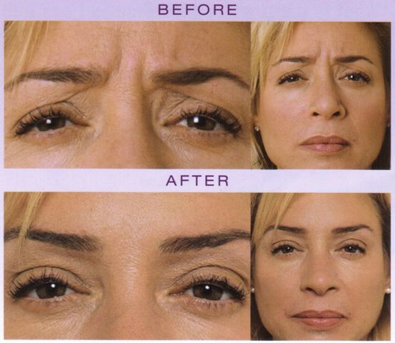

Skin care and laser treatment

[Skin Care with Retin-A, Obagi](http://www.plazaclinic.net/skincare.html#retin-a)

[Lasers for Brown Spots, Wrinkles, Red Face, etc.](http://www.plazaclinic.net/skincare.html#lasers)

[Laser for Hair Removal](http://www.plazaclinic.net/skincare.html#hairremoval)

[Laser for Stuffy Nose and Nasal Allergy](http://www.plazaclinic.net/skincare.html#stuffynose)

Men’s wellness

[Erectile Dysfunction (ED)](http://www.plazaclinic.net/mens.html#ed)

[Androgenic Alopecia (Male Pattern Baldness)](http://www.plazaclinic.net/mens.html#aga)

[Brown Spots, Wrinkles, Skin Care](http://www.plazaclinic.net/mens.html#brown)

[Surgeries](http://www.plazaclinic.net/mens.html#surgeries)

**Doctor’s credentials**

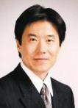

Robert Katsuhiro Kure, MD  
*board certified by American Board of Plastic Surgery*

* Born in Japan
* U.S. Naval Hospital Yokosuka graduate
* Albert Einstein College of Medicine, New York
* Surgical residencies at university hospitals in USA
* Plastic Surgery residency at UCLA Medical Center
* Chief Resident of Plastic Surgery at UCLA (99-2000)
* Private practice in Beverly Hills and New York City
* Diplomate of American Board of Plastic Surgery
* Active Member, American Society of Plastic Surgeons

**Mineo Orito, MD**board certified by American Board of Plastic Surgery

* 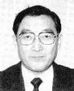Born in Japan
* University of Tokyo (MD) graduate
* Albert Einstein College of Medicine, New York
* Surgical residencies at university hospitals in USA
* Plastic Surgery residency at SUNY, New York
* Chief Resident of Plastic Surgery at SUNY
* Private practice in New York City and Tokyo
* Diplomate of American Board of Plastic Surgery
* Active Member, American Society of Plastic Surgeons

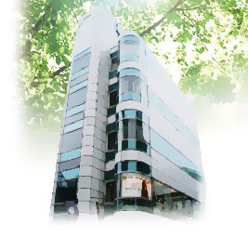

**Contact us**

U.S. Board-Certified Plastic Surgeons in Tokyo Japan

PLAZA　PLASTIC SURGERY

[info@plazaclinic.net](mailto:info@plazaclinic.net)

By Telephone  
03-5475-2345  
(English is spoken)